
CAMS HILL SCHOOL
CENTRE No. 58105

EXAMINATIONS -
CANDIDATES’ HANDBOOK
SEPTEMBER 2025 TO AUGUST 2026

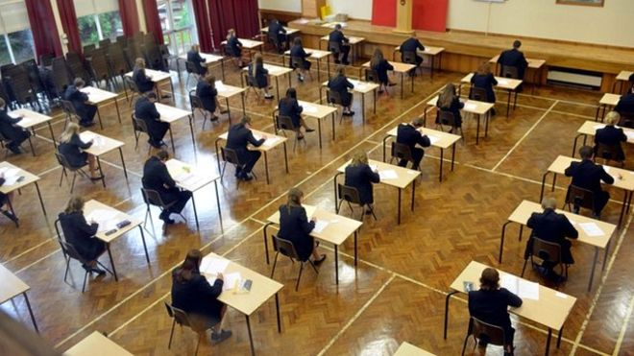

Contents
1. Introduction 3
2. Before the Examinations 4
Examination Boards 4
Candidate Number 4
Centre Number 4
Statement of Entry 4
Timetables 4
Equipment 4
3. During the Examinations 5
Regulations 5
Start of examinations 6
Conduct in the examination room 6
Invigilators 7
Absence 8
Special Consideration 8
Access Arrangements 8
4. After the Examinations 8
Notification of results 8
Post results 9
Collection of Certificates 9
5. Examinations Checklist 9
6. Frequently asked questions 11
7. GCSE Exam Results Day 12
GCSE Exam Results Day 12
Thursday 20 August 2026 12
Cams Hill School Authorisation Form for the Collection of GCSE Provisional Exam Results on Thursday 20 August 2026 14

Introduction

Examinations play a very important part in your life at Cams Hill School. The examinations that you take this year will have an impact on what you do in the future, so we want to make sure that they run smoothly for you.

This booklet has been produced to help you prepare for your forthcoming examinations. Please read it carefully and share it with your parent(s)/carer(s) so that they are also aware of the examination regulations and the procedures to follow.

There are a number of rules and regulations for examinations that you must be familiar with, most of which are set by the Examination Boards, not by the School. Also, please make sure that you are fully aware of the rules and regulations, timings of examinations and arrangements made for you.

Particular attention should be paid to the notices and warnings to candidates in this booklet. It is the candidate’s responsibility to read and understand these notices.

Some of the questions you may have are answered in the section ‘Frequently asked questions’, however, if there is anything you do not understand or any question that has not been addressed please ask your Tutor, your Subject Teacher or the staff listed below:

Examinations Officer Mrs O Ure
Examinations Administrator Mrs K Radestock
Head of Year 11 Mrs C Fields
Senior Line Manager for Examinations Mrs P Newman

The school telephone number is: 01329 231641
E-mail address: exams58105@camshill.com or office@camshill.com

Please remember we are here to help!

Before the Examinations

Examination Boards

The school uses the following Examination Boards (awarding bodies):
AQA – www.aqa.org.uk
Pearson (also known as Edexcel) – https://qualifications.pearson.com/
OCR – www.ocr.org.uk
WJEC – www.wjec.co.uk
NCFE - www.ncfe.org.uk

Their websites contain a wealth of information. Joint Council for Qualifications (JCQ) regulations state that “Awarding bodies will only communicate with centres regarding examination administration. Awarding bodies will not communicate with candidates or their Parents/Carers except in exceptional circumstances and at their discretion”.

Candidate Number

You have been allocated a four-digit Candidate Number. This is the number you will enter on examination papers. It will appear next to your name on seating plans and examination registers. Pupils are asked to enter this number on every examination paper they sit.

Centre Number

The Centre number for the School is 58105 which you will also be required to put on every examination paper.

Statement of Entry

All Candidates receive a Statement of Entry from the School indicating the subjects they are being entered for and the levels of entry, where applicable. Please check that these are correct. Some subjects only have one tier of entry; some have Foundation and Higher tiers.

Timetables

Dates and times for practical examinations such as Art, Photography, Graphics, Music, Drama, BTECs and Design Technology will be posted on the examination noticeboard. For all other examinations you will receive an individual timetable. This will show your own personal examinations. If you think something is wrong, you MUST inform Mrs Ure, the Examinations Officer, immediately. Check each examination date and time carefully so that you know if the examination is in the morning or the afternoon. If you have more than one examination at the same time, please talk to the Examinations Officer to decide which order you will take them in and where.

Equipment

You MUST bring the correct equipment with you for your examinations:

- at least two black pens, a pencil, a rubber and a ruler to every examination;
- a calculator to the Mathematics (calculator) examinations, all Science examinations and any other subject where it could be useful, but NOT to the non-calculator Mathematics examination.

JCQ: “Candidates may use a calculator in an examination unless prohibited by the awarding body’s specification. Where the use of a calculator is allowed, candidates are responsible for making sure that their calculators meet the awarding bodies’ regulations.”

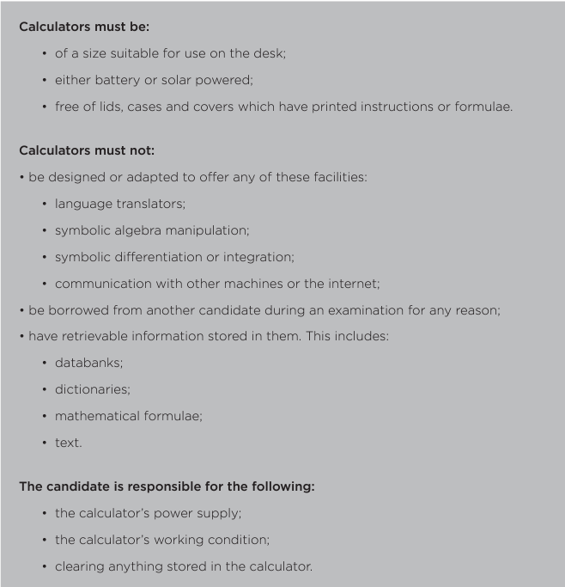

It is your responsibility to make sure you have the correct equipment. If something breaks or runs out during an examination the invigilators will try to replace it, but you should bring spares with you wherever possible.

During the Examinations

Regulations

The JCQ link to candidate information documents is: https://www.jcq.org.uk/exams-office/information-for-candidates-documents/

These exam room posters will be displayed outside all examination rooms:

- JCQ Warning to Candidates
- JCQ Unauthorised items

All candidates must read these carefully and note that any breach of the rules could lead to disqualification from some or all subjects.

Start of examinations

- For all examinations you must line up on the hard courts nearest the Humanities block. Most examinations will be taken in the Sports Hall, although some smaller or more specialised examinations may be taken in other classrooms around the school. For morning examinations, you must be lined up by 0830 am outside the Humanities block in your tutor groups.

- If you arrive late for an examination you may still be admitted, depending on how late you are, but it may not be possible for you to receive any additional time at the end of the examination. Completed examination papers will be sent to the Examination Board, however we are obliged to send a full report to the Examination Board and the Examination Board may not accept your work.

- You must be in full school uniform for all examinations.

- Pupils and parents/carers should be mindful of the contingency days set by the exam boards. The contingency session are as follows:

All day Wednesday 24 June 2026

The designation of a “contingency day” by the awarding bodies is in the event of national or significant local disruption to examinations. It is part of the awarding bodies’ standard contingency planning for examinations. Please note your child must remain available until close of play on Wednesday 24 June 2026 should an awarding body need to invoke its contingency plan and run exams on these days.
- All items of equipment: pens; pencils, mathematical instruments, etc, must be visible to the invigilators at all times. They should be in a transparent pencil case or clear plastic bag, and must not be put back in pockets until you have left the examination room.

- Pens must contain black ink.

- For exam papers where calculators are allowed, you should bring your own calculator. Remove any covers or instructions and make sure the batteries are new. There should be nothing stored in the memory of the calculator, they will be checked on the way into the examination room and if the invigilator cannot clear the memory you will not be allowed to take it in with you, so please make sure you know how to clear the memory.

- You may take a clear bottle of water into the examination room, but labels must be removed. No food (including chewing gum) is allowed into the examination room. If you have a special requirement, please see the Examinations Officer before the start of the examination period. Make sure you eat a good breakfast before coming to school; it will help you to concentrate.

Conduct in the examination room

- You must be silent at all times; from the moment you enter the room until you are back outside after the examination. If you have a problem, put your hand up clearly and wait for an invigilator to attend to you. If you need to leave to visit the toilet or the medical room you must put your hand up and wait to be escorted by an invigilator.

- Do not attempt to communicate with or distract other candidates. Face the front and do not turn around.

- Do not bend down to pick up items you have dropped, put up your hand and an invigilator will pick it up for you.

- No electronic devices (other than calculators, see previous note) or watches are allowed in the examination room (refer to the JCQ notices for information on what is an unauthorised item). If you are found to have any unauthorised material in your possession during an examination, it will be taken from you and a report sent to the appropriate Examination Board.

- Listen carefully to verbal instructions and notices – there may be amendments to the examination paper that you need to know about.

- Check that you have the correct examination paper – check the subject, paper and tier of entry. If you think you have the wrong paper, please inform the invigilators immediately.

- Read all instructions carefully.

- You must stay in the examination room for the duration of the examination. You will not be allowed to leave an examination room early. If you have finished, use the remaining time to check over your answers.

- If the fire alarm sounds during an examination, the invigilators will tell you what to do. If you have to leave the examination room you will be asked to leave in silence and in the order in which you are sitting.

  - You will be escorted to the assembly point.
  - You must leave everything on your desk.
  - You must not communicate with anyone whilst you are out of the examination room (as this will have to be reported to the Examination Board and you may be disqualified from the examination).
  - When you return to the examination room do not start working until an invigilator tells you to do so.
  - You will be given the full amount of time allowed for the examination. You will not be disadvantaged in any way.

- At the end of the examination all work must be handed in – remember to cross through anything that you do not want to be marked. If you have used extra examination stationery, make sure that you have filled in all required details and attach it to the examination paper.

- All papers will be collected before you leave the examination room. You must not put your hands in your blazer and/or trouser pockets until you are outside the examination room; all equipment should be carried in your hand until you are outside.

- Question papers, answer booklets and additional paper must not be taken from the exam room.

- Remain seated in silence until you are dismissed. Examination conditions apply until you are outside the examination room. Once outside the examination room please show consideration for other candidates who may still be working and move away from the examination room quietly.

Invigilators

- The School employs external staff to conduct/invigilate the examinations. You are expected to behave in a respectful manner towards all invigilators and follow their instructions at all times.

- Invigilators are in the examination rooms to supervise the conduct of the examination. They will tell you when to start and finish the examination, distribute and collect examination papers, hand out extra writing paper, if required, and deal with any problems during the examination, for example if you feel unwell.

- Invigilators cannot discuss the examination paper with you or explain the questions.

Absence

- If you experience difficulties during the examination period (eg illness, personal problems) please inform the School as soon as possible so that we can help or advise you.

- If an examination is on your timetable, you must attend. Misreading the timetable will not be accepted as a valid explanation of absence.

- The School pays the Examination Boards for you to sit examinations, therefore your parent(s)/carer(s) will be charged if you fail to attend an examination without a valid reason.

Special Consideration

- If your performance in an examination has been affected by illness, injury or bereavement, the School can apply to the examination board for Special Consideration. This is an adjustment made after the paper is marked to prevent you from being disadvantaged from something outside your control. If after an examination you think you have good reason for applying for Special Consideration, you should see the Examinations Officer immediately, as we only have a few days in which to make the application. There are very strict rules about applying for Special Consideration, and the decision lies with the Examination Board.

- In exceptional circumstances, it may be possible to apply for Special Consideration where a candidate misses an examination paper through illness or personal misfortune. A minimum of 25% of the total assessment must have been completed. However, an award cannot be made where none of the components/units within a specification have been completed.

- The School must have medical or other appropriate evidence in all cases before an application can be made for Special Consideration. There are strict deadlines for these applications and it is therefore essential that this is obtained by the candidate/parent/carer on the day of the examination and given to the Examinations Officer within three days of the examination.

Access Arrangements

- A number of pupils receive Access Arrangements for examinations, which have been awarded in accordance with strict JCQ regulations. If you have any queries regarding your Access Arrangements, please speak to Mrs Ure (Examinations Officer), Mr Haines (Head of Learning Support Department/SENDCo) or Mrs Ashdown-Knights (Assistant to the SENDCo).

4. After the Examinations

Notification of results

- Results for the summer examinations will be available for collection on: Thursday 20 August 2026 between 9.30 am and 10.30 am.

- If you wish for someone else to collect your results (eg parent/carer, sibling, grandparent) we ask that the person collecting has photo identification with them and a letter signed by you as the candidate, giving permission for them to collect the results on your behalf (the attached Authorisation form can be used).

- No results can be given out by telephone or by e-mail.

- Results that are not collected by 11am on the date above will be posted to the home address we have on record for you. Please keep us up-to-date with any changes to your contact details.

- If you wish for results to be posted to an alternative address please inform us, in writing, by Friday 3 July 2026.

Post results

- If you need post-results advice, please speak to the appropriate subject staff or to the Examinations Officer.

- Subject staff routinely check results and if they consider it appropriate to put in for a Review of Marking to the Examination Board, they will contact you.

- If a Review of Marking is submitted the result can go down as well as up. Consequently, no application can be made unless you come into school to sign a form giving your consent.

- It is possible for candidates to request a Review of Marking, however, in this instance we ask the parent(s)/carer(s) to meet the cost. If the Review of Marking results in a grade change, the fee is refunded by the Examination Board. If you would like to apply for the Review of Marking please contact the Examinations Officer.

- Further information about this service will be posted on the school website during the Summer Term when the specific details have been published by the Exam Boards.

Collection of Certificates

- Your parent/carer will receive an email inviting you to collect your certificates in Autumn 2026. This date will also be published on the school website and via the school’s social media.

- If you wish for someone else to collect your certificates (eg parent/carer, sibling, grandparent) we ask that the person collecting has photo identification with them and a letter signed by you as the candidate, giving permission for them to collect the certificates on your behalf.

- Look after your certificates when you receive them, the only way to replace them is through the Examination Board and they charge approximately £50 per certificate.

5. Examinations Checklist


Aim to arrive at school in plenty of time for your examination, you should be lined up on the hard courts outside the Humanities Block, or Library if you are entitled to Access Arrangements, at least 20 minutes before your examination. If you are very late you may not be allowed to take the examination, so if you are unavoidably delayed on the day of an examination please contact the Examinations Officer as soon as possible.

When taking examinations, bags and coats will normally be left outside of the examination room or in a designated area as directed by the invigilators.


Mobile phones are not allowed in school, however, in the event that you do find you have your mobile phone with you, it must not be taken into the examination room even if it is switched off. It should be left TURNED OFF in your bag. If a phone is found to be in the examination room you will be penalised by the Examination Board. The same rule applies for Smart Watches, watches and any other electronic devices.

You should bring all of your examination equipment with you, it should be in a clear pencil case. There is no need to buy something expensive, a clear sandwich bag will do. Mathematical equipment should not be in metal containers. Calculator lids are not permitted.

Once you enter the examination room there is to be no talking or communication between pupils. If you have any questions, you should raise your hand once seated and an invigilator will come to you.



You may take a clear, transparent bottle of water into the examination room, with no logo and all labels must be removed. No food (including chewing gum) is allowed in the examination room (if you have a special requirement please see the Examinations Officer before the start of the examination period). Make sure you eat a good breakfast before coming to school, it will help you concentrate.

Pupils will not be allowed to leave the examination room before the scheduled finish time of the examination. You will be advised when you can leave. Please be patient whilst examination material is being collected, and refrain from any form of communication until you are outside the examination room.

Ensure you go to the toilet before the start of an exam. If you absolutely need to go to the toilet during an examination, you must put your hand up and you will be escorted to the toilet either by an invigilator or a member of staff. We strongly discourage the use of toilets in the last 15 minutes of the examination.

It is imperative that you check you have been given the correct examination paper, as there can be several examinations taking place at the same time. If you think you have the wrong paper, put your hand up and speak to an invigilator. We cannot give you extra time if you realise part way through a paper that you are doing the wrong one or the wrong tier.

If you feel ill during an examination, please bring this to the attention of the invigilator as soon as you can, even if you want to continue with the paper.

Frequently asked questions

Q. What items are not allowed into the examination room?
- Only materials that are listed on question papers are permitted in the examination room and pupils who are found to have any material with them that is not allowed will be reported to the appropriate examinations board. In such circumstances, a pupil would normally be disqualified from the paper or the subject concerned.
- Bags and coats and any other items not permitted under examination regulations must be left in the designated area. Do not bring any valuables into school with you when you attend examinations.
- No food or drink (other than a clear bottle of water with no logo or labels) is allowed in the exam room.
- If you have a mobile telephone (or any other electronic communication device, eg iPod, iWatch, MP3/4 player, headphones, smart wrist watch/band with data storage properties, watch) it must be turned off and placed in your bag before entering the examination room, however if you find that you still have your phone/electronic device/watch on you once you’ve entered the examination room you MUST hand it to an invigilator before the start of the examination.

Q. Why can't I bring my mobile telephone into the exam room?
- Being in possession of any potential technological/web enabled sources of information such as a mobile phone, iPod, iWatch, MP3/4 player or smart wrist watch/band which has data storage properties is regarded as cheating and is subject to severe penalty from the awarding bodies.

Below are the penalties that exam boards may impose on pupils found with a mobile phone on them:

- Device found on you and turned ON – disqualification for the entire subject award.

- Device found on you and turned OFF – disqualification from the specific paper you are sitting at the time.

- Phone rings during the exam wherever it is in the room - the awarding body must be informed and you will be disqualified from all papers for the subject (including any already taken).

Q. How do I know how long the exam is?
- The length of the examination is shown on your individual timetable. Invigilators will tell you when to start and finish the exam. They will write the finish time of the exam on the board at the front of the exam room, or on a piece of paper if you are taking an examination in a small room. Timings will be by the clock(s) in the examination room(s).

Q. Can I leave the exam early?
- It is a requirement of the awarding bodies that you must stay in the examination room for at least one hour after the published start time of the exam (or for the duration of the exam if less than one hour). It is School policy not to allow candidates to leave the exam room early as this is disruptive to other candidates. A candidate may not leave the examination room without the permission of the invigilators. If you have finished the paper, use any time remaining to check over your answers and that you have completed your details

Q. What do I do if the fire alarm sounds?
- The examination invigilators will tell you what to do. If you have to evacuate the room, leave everything on your desk and leave the room in silence in the order instructed. You must not communicate with any other candidates during the evacuation and are reminded that examination rules apply throughout the period of evacuation. You will be told when it is safe to return and on entering the examination room should return to your seat and wait for the invigilators to formally re-start the exam. The finish time will be amended to ensure the prescribed length of exam is given.

Q. Can I go to the toilet during an exam?
- Only if it is absolutely necessary. You will be escorted by an invigilator and will not be allowed any extra time. It is good practice to go to the toilet before lining up to enter the exam venue.

Q. Why do I need to check the details on the Statement of Entry?
- The details on your Statement of Entry will be used when certificates are printed. If the name or date of birth on your certificates does not match your birth certificate it could cause you problems if you are asked to show your certificates to a potential employer or college/university at some time in the future. You should also check that the subjects and tiers of entry you are entered for are correct and that no subjects are missing.

Q. Why shouldn’t I use my preferred name on my exam papers?
- All exam entries are submitted to the awarding bodies using your legal name and this is what will appear on your exam certificate. To use your preferred name causes a mismatch with the awarding body records and could delay the issue of results.

Q. I am entitled to extra time – how will this affect the way I take my exams?
- Following an assessment for Access Arrangements, some pupils receive an allowance of up to 50% extra time for some of their examinations. The invigilators are made aware of such candidates and they will inform you of your altered finishing time. You do not have to use the extra time and are allowed to leave before this time runs out but you must ask an invigilator for permission before you leave. Also, use this time wisely. So, if you have answered all the questions, you may use the rest of the time to go over your work and check your answers.

Q. What do I do if I don't get the grades I need?
- You will be advised on what to do if this is the case on Results Day. If you feel strongly that it is necessary to submit a Review of Marking you should obtain advice as to the advisability of requesting a Review of Marking. You should be aware that your mark could go down as well as up or even stay the same. Review of Marking requests must be submitted to the Examinations Officer by Friday 11 September 2026. You must complete a Candidate Consent Form and return it with a cheque addressed to Cams Hill School to cover the cost (NB the cost of a Review of Marking is approximately £40 per unit). If your grade changes, your cheque will not be cashed.

GCSE Exam Results Day

GCSE Exam Results Day

Thursday 20 August 2026
Pupils may collect their provisional results from the School in person between 9.30 am and 10.30 am.

Any provisional results not collected by 11am will be posted to the pupil’s home address. If a pupil expresses a wish for someone else to collect their results (eg parent/carer, sibling, grandparent) we ask that the person collecting has photo identification with them and a letter from the pupil giving permission to collect the results on their behalf.

We regret that it is not possible for us to give the results over the phone or by email. However, we can post them to an alternative address, provided we receive a request in writing by Friday 3 July 2026.

Please keep us up to date with your contact email and postal address, so that we are able to supply you with the information you will require for the collection of Certificates in late Autumn 2026, and to ensure that any posted provisional results slips are sent to the correct address.



Cams Hill School Authorisation Form for the Collection of GCSE Provisional Exam Results on Thursday 20 August 2026

Authorisation form for another person to collect GCSE Provisional Exam Results/any certificates available on 20 August 2026 on your behalf. (Delete as necessary)

I ……………………………………………………………………………… (name in capital letters) give permission for

……………………………………………………………………………….. (name in capital letters) to collect my GCSE
Provisional Results/any certificates on Thursday 20 August 2026.

I accept that Cams Hill School will not be responsible for my provisional results or certificates once they have been collected.

Signature of pupil: ………………………………...…….……………………….……. Date: ……………………….………….……….

Signature of authorised person: …………………………………………………… Date: …………………………………………...

The authorised person will need to bring with them this form and photo ID.



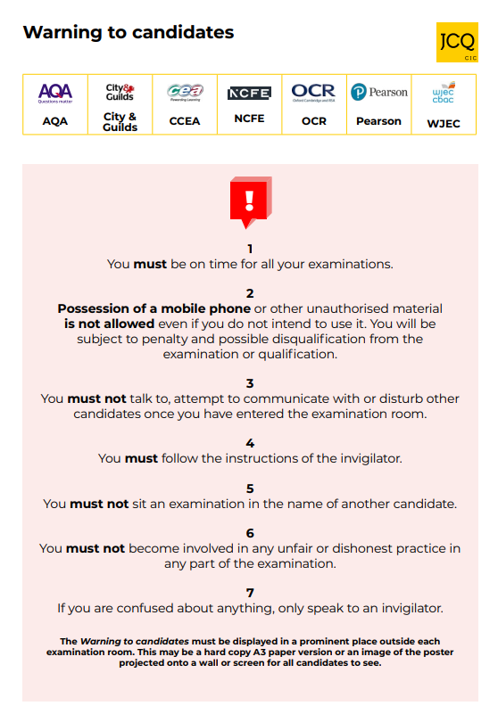
Please familiarise yourself with the following JCQ documents:
https://www.jcq.org.uk/exams-office/information-for-candidates-documents/
- Information for candidates – coursework 2025-2026
- Information for candidates – non-examination assessments 2025-2026
- Information for candidates – on-screen tests 2025-2026
- Information for candidates – written exams 2025-2026
- Preparing to sit exams
- Information for Candidates – Social Media 2026

