Cams Hill School

PRAISE AND REWARD POLICY

Non- Statutory
Date Created: 25 April 2017
Review Period: Annually
Last Reviewed: 13 July 2020
Ratified by Governors: N/A
Next Review Date: 12 July 2021

Contents
Introduction 3
Aims 3
Principles/Values 3
Consultation 3
Procedures and Practice 3
Achievement Points 4
Praise and Reward Pyramids 5
Practice and Guidelines for Rewarding Achievement Points 6
Postcards Home 6
#hotchocfriwiththeht 6
Tutor Group Reward 6
On Target and Attitude to Learning Commendation 6
Rewards Hub 6
House System 7
Celebration Assemblies 8
Leadership Team Stars 8
Headteacher’s Commendation 8
End of Year Awards Evening 8
Rewards Trip 8
Concluding Notes 8

Introduction

The role of rewards in recognising and promoting Cams Hill School values is a key part of developing the potential of young people by giving encouragement and praise. Praise is a key component of good teaching and good staff/pupil relationships. Good behaviour is also best promoted and developed by drawing attention to and rewarding well-behaved and hardworking pupils. Praise should be used appropriately, sincerely and be linked to tangible examples of a pupil’s strengths.

A reward system must be of value to the pupils, parents and staff. The rewards system at Cams Hill is a system which provides a vehicle to measure and monitor progress and success via a broad range of opportunities. It has a hierarchical structure to allow for progression and challenge. The rewards system is designed to reflect all aspects of school life. The school will use all available means to publish and promote achievement by all members of the school.

At Cams Hill we recognise that pupils thrive on praise, the thrill of success and the glow of recognition. Praise rewards the deserving, can inspire those who may be struggling and can inspire and motivate those who may be disenchanted. Finding ways to reward must be at the heart of our teaching.

Aims

• To be inclusive for all.
• To recognise and celebrate a pupil’s work, commitment and high levels of achievement.
• To promote the positive recognition of success amongst all members of the school community through public celebration and contact with parents and carers.
• To celebrate progress made by the pupil.
• To encourage progress in all aspects of school life.
• To reward pupils frequently for a variety of achievements.

Principles/Values

This policy supports the school’s beliefs of ‘Inspire, Nurture, Achieve and Excel’

Consultation

This policy was written by Pippa Newman, Associate Assistant Headteacher and leader of Praise and Rewards in consultation with:

Gwennan Harrison-Jones – Headteacher
Aly Potts – Assistant Headteacher - pupil culture; inclusion; standards, progress and achievement.
Pupils - Focus groups, working groups, school council, pupil survey and tutor group discussions.

Procedures and Practice

All staff should be actively engaged in carrying out this policy.

We provide a shared ownership of the Praise and Rewards Policy by:

- annually monitoring and evaluating the rewards system to ensure quality, consistency and effectiveness;
- communicating expectations to all members of the school community including the policy as part of the induction process;
- offering differentiated rewards according to age.

Pupil achievements can be rewarded in other ways such as:

- praising behaviour, achievement and improvement both in and out of school. Positive feedback is a great motivator, and may be a written comment in an exercise book, pupil planner, or a quiet or public word;
- displaying work, eg on the board, in the weekly bulletin;
- using assemblies/tutor time to publicly recognise successes;
- prizes for competitions;
- progress prizes;
- departmental awards/departmental postcards posted home;
- phone-call home;
- Bronze, Silver, Gold and Platinum postcards/certificates home along with the awarding of lapel badges at Silver, Gold and Platinum level;
- formal occasions such as Awards Evenings at the end of the academic year;
- roles and responsibilities, eg Tutor Representatives, House Captains, School Council, Pupil Leadership Opportunities;
- House Points;
- Rewards Hub;
- Senior Leadership Team commendations for exceptional behaviour/work ethic;
- Headteacher’s commendation.

Achievement Points

We believe that success and effort should be rewarded. Pupils are awarded ‘Achievement Points’ for success both in and outside of lessons. These are recorded on Edulink. At the appropriate time postcards/certificates will be awarded when a pupil has achieved the Bronze, Silver, Gold and Platinum thresholds. Tutors and/or Heads of Year will follow up the awarding of these postcards/certificates with a telephone call home to tell parents/carers of their child’s success. Attached members of the Senior Leadership Team will also award certificates to pupils who achieve the appropriate amount of achievement points. A pupil who receives the required amount of achievement points to qualify for a lapel badge will be invited to meet with the Head of Year, Assistant Headteacher or the Headteacher to be presented with it. If a pupil achieves the appropriate amount of achievement points to qualify for the Platinum lapel badge, then the pupil will be invited to meet with the Headteacher and a School Governor in order to be presented with it and have afternoon tea.

Any pupil who receives a Silver lapel badge will automatically be eligible to go on the Rewards trip at the end of the Summer Term.

Praise and Reward Pyramids

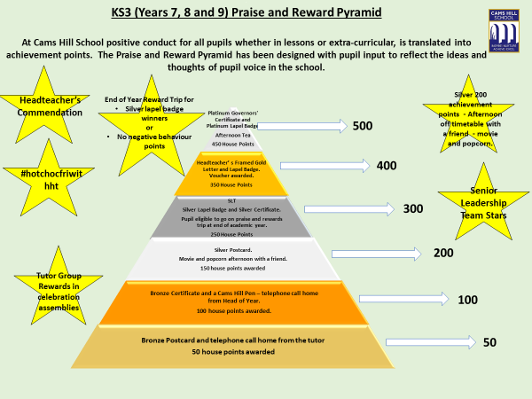

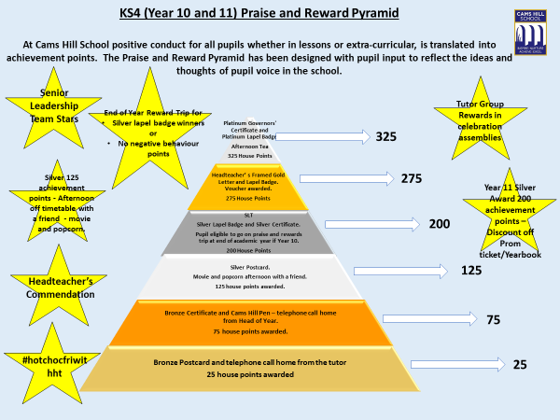

Practice and Guidelines for Rewarding Achievement Points

Achievement points are awarded for standards achieved above 'normal' expectations.

- Individual achievement points will also be added to tutor group totals.
- Total points score will be seen by both pupils and parents on Edulink in real time.
- Achievement points are awarded by all teaching staff/LSAs for daily achievements by individual pupils both inside and outside of lessons and, where warranted, should be awarded on a regular basis centred on the guidelines.
- All members of staff can award achievement points outside of lessons (see guidelines).
- The achievement point system also works alongside the House system with pupils receiving house points to go towards their house totals throughout the year.

Consistency is key to making this a success and there is an expectation that all staff will award achievement points for work/actions that deserve it.

Postcards Home

Postcards are sent home to our pupils and parents/carers to recognise and praise a pupil for a particular achievement, act or effort. The exceptionally positive feedback from pupils and parents/carers alike, suggests that this method of rewarding our pupils is highly valued and appreciated by all. All subject teachers, as well as the pastoral teams, use postcards to celebrate achievement and pupils really value receiving postcards as they provide them with a physical reward as recognition of their hard work, effort and commitment. Postcards are linked to the achievement point system across all year groups.

#hotchocfriwiththeht

In order to acknowledge and celebrate achievement points regularly amongst individual year groups, we use our weekly electronic records to recognise our Achievement Point Champs of the Week. Our winning pupils are identified in each year group as having achieved the highest number of achievement points in one week. These pupils are invited to meet with the Headteacher each Friday at break and enjoy a hot chocolate. This highly successful method is another means of consistently and regularly supporting, recognising and celebrating pupils in their everyday learning and behaviour.

Tutor Group Reward

At the end of each term, the tutor group in each Year group with the highest total of achievement points, after negative behaviour points have been deducted, will be awarded a special ‘treat’, which will be decided upon by the individual winning tutor group, in consultation with their tutor and respective Year Team.

On Target and Attitude to Learning Commendation

Throughout the school year, at different times, all Year groups have regular data drops which record pupils’ attitudes to learning as well as their progress. All those pupils who are on track in 70% or more of their subjects and have outstanding attitude to learning grades (they sit in the green quadrant) will receive 20 achievement points from their Head of Year. This will be further followed up with a letter home, congratulating pupils on their success. These pupils are also recognised in the end of term celebration assemblies.

Rewards Hub

Cams Hill School Rewards Hub recognises the hard work/behaviour/attitude to learning of Year groups by providing a space for pupils to sit and engage at breaktime and lunchtime with games such as pool, table tennis and computer games eg the Nintendo Switch. Year groups are publicly recognised weekly for their achievements and are informed who can use the Hub at the start of each week.

House System

The school prides itself on its very active House System whereby all staff and pupils are assigned to one of four houses. Being close to the home of the British Navy, they comprise of:
- Endeavour
- Invincible
- Warrior
- Illustrious
At Cams Hill School we celebrate the successes of all our pupils who strive to achieve their best in all aspects of their life in school. The House System is directly linked to the Praise and Rewards Pyramid and gives our students the opportunity to be rewarded for efforts and achievement in all areas. For each stage achieved by a pupil on the pyramid, a number of house points are awarded to the appropriate house.
The primary aim of the House System is to encourage all pupils to get involved in the many inter-house competitions within subjects and extra-curricular activities.
- Each House has both Staff House Leaders and Pupil House Captains who have been voted for by their fellow pupils. Pupils are involved in running and publicising house events, thus promoting pupil leadership and responsibility.
- Competition between the Houses is fierce and always very close and exciting.
At the end of the academic year the House with the highest number of house points receives an afternoon off timetable, where they will have a barbeque and take part in other fun activities.
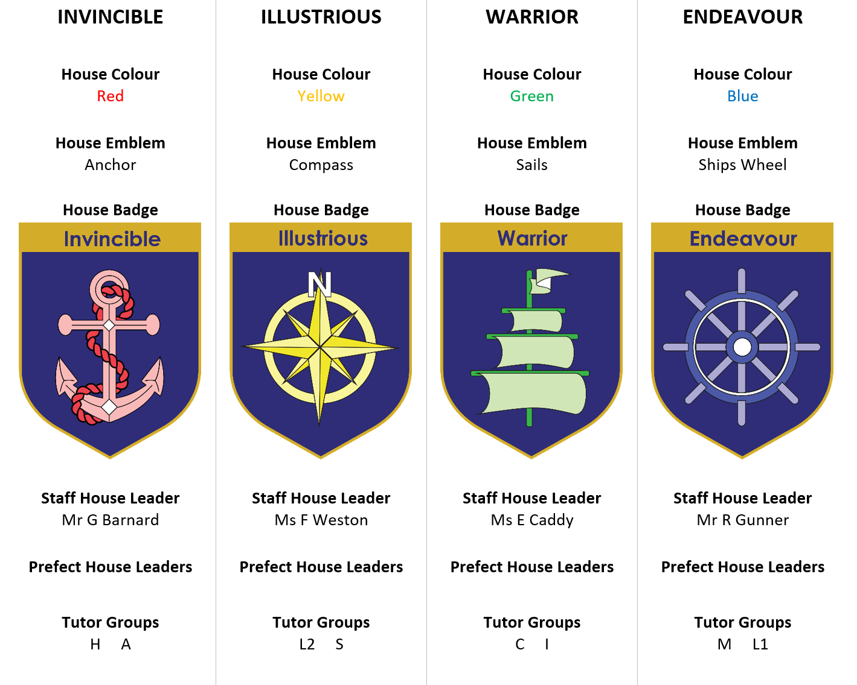

Celebration Assemblies

Celebration Assemblies are held termly and are an excellent opportunity to celebrate achievements in a less formal, celebratory manner. Through analysis of our achievement point system and attendance records, we use Celebration Assemblies to praise and recognise the whole term successes of pupils who have consistently and continuously pushed themselves to achieve well. This termly event involves all of the Year Team and Form Tutors, along with attached members of the Senior Leadership Team. These assemblies provide our pupils with an invaluable opportunity to support, share and celebrate each other’s successes together; which, in turn, promotes an acceptance of positive achievements and excellent behaviour.

There are a wide range of categories that pupils are recognised for in these Celebration Assemblies. These include rewards for attendance and punctuality, rewards for excellent Attitude to Learning grades, rewards for behaviour and rewards for the number of achievement points achieved. Pupils very much value being recognised for their successes.

Leadership Team Stars

These will be awarded by members of the Senior Leadership Team when visiting classrooms. The teacher may be asked to nominate a pupil (discretely) who has demonstrated exceptional progress/effort over a sustained period of time. Each pupil will be given 50 house points and every half term the pupils awarded a Leadership Team Star will be entered into a draw for a prize.

Headteacher’s Commendation

Each term, exceptional pupils are nominated by staff for outstanding contributions to the school community both in and out of the classroom. This can be for academic achievement or success beyond the classroom as well as in the wider community outside of school hours. Pupils who are awarded a Headteacher’s commendation will be recognised in the weekly message and on the school website as well as at Governor Meetings.

End of Year Awards Evening

These are held at the end of the Summer Term. Pupils invited to the evening, receive their awards for academic achievement, progress and effort, along with individual subject awards and school special awards.

Rewards Trip

Any pupil who receives the appropriate number of individual achievement points, or receives no negative behaviour points, is eligible to go on the Rewards trip at the end of the Summer Term.

Concluding Notes

This policy will be reviewed annually and should be read in conjunction with our policies for Equalities & Diversity and Good Behaviour.

