

**What is being studied this year:**

* Generating design ideas and design development
* Drawing for design using hand and CAD drawing methods.
* 3D modelling techniques.
* Materials, techniques and processes
* Social and moral issues
* Planning for manufacture
* Product manufacture – 3D practical element
* Mock GCSE Exam preparation
* Exam preparation - Review of design theory, knowledge of materials and processes and skills learnt.

**Exam Board Details:**

**AQA D&T Product Design 4555 – The course is made up of the following two units.**

**Unit 1: Written Paper (45551)**

40% of total marks

2 hours

120 marks

There are two sections to the exam. One part is a design task and requires the students to respond to pre-released material from the exam board.

**Unit 2: Design and Making Practice (45552)**

60% of total marks

Controlled assessment folder

90 marks

Consists of a single design and make project. Students will be guided to choose one of the set tasks sent from the exam board.

Students must produce a concise design folder that consists of approximately 20 pages of A3 paper. It must focus on the development of a product and consist of appropriate ICT evidence.

It is expected that students should spend approximately 1-2 hours working on their controlled assessment folder outside class time.  
As part of the evidence submitted, students should include photographs of the finished products as well as photographs at various stages of the process including any trial practical work completed outside school.

Product Design

**What Can You Do To Support Your Child?**

Catch up sessions run every **Mondays 3.20 – 4.40**

**Thursday week B 3.20 – 4.40**

**Useful websites:**

www.technologystudent.com

www.mrdt.com

[www.gcsebitesize.com](http://www.gcsebitesize.com)

[www.dtonline.org](http://www.dtonline.org)

[www.designandtech.com](http://www.designandtech.com)

[www.design-technology.info](http://www.design-technology.info)

Don’t forget to check out <https://uk.pinterest.com> great for looking at innovative new products and for learning drawing and workshop techniques.

**Books for Controlled Assessment coursework and Revision:**

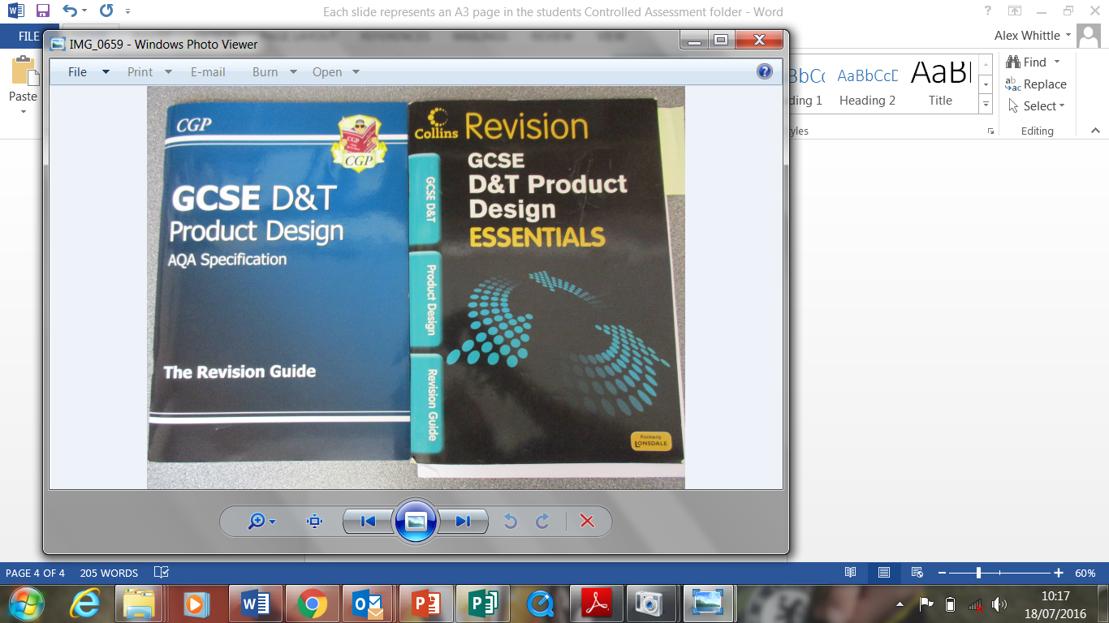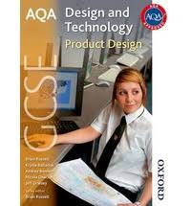

All students must practice and use relevant Computer Aided Design software.

**Tinkercad.com** and **Google SketchUp.com** are free online and downloadable design software that all Product Design students should be learning to use. Tutorials with the software will help to develop skills. We cannot allocate any more class time to CAD so this should be regularly practiced at home.

Nearly all class time during the latter part of the autumn term is taking up with practical work. The practical making counts for 32 marks (one of the largest sections) of the controlled assessment which in total 60% of the overall GCSE Product Design grade.

**How else can you help?**

You can support your child by overseeing that they complete 1-2 hours of homework per week. This could be a combination of students independently set and teacher targets for controlled assessment work and revision.

An ideal way to support your child would be to help proof read written work in their controlled assessment folder and support them with gathering materials for their practical outcome.