

**Exam Board Details:**

All students are entered for the AQA GCSE Examination. No more controlled assessments just final examinations at the end of Year 11

•          **25% Listening (May/June yr2)**

**(F 30mins + 5mins/H 40mins + 5mins)**

•          **25% Reading (May/June yr2)**

**(F 45mins/H 60mins) Questions in English and Target Language as well as translation of short passages**

•          **25% Speaking (May/June yr2)**

**(three activities : role play, discussion based on a photo as well as a general conversation)**

**duration :7 to 12 minutes**

•          **25% Writing (May/June yr2)**

**(F 60 min/H 75mins) Structured writing tasks as well as open ended ones and translation activities**

F= Foundation Tier

H= Higher Tier

Students need to be entered in the same tier for all the different units/examinations.

**French** 

**Reading & Listening exams 15th May**

**Writing exam 18th May**

**Spanish** 

**Reading & Listening exams 6th June**

**Writing exam 14th June**

**German** 

**Reading & Listening exams 18th June**

**Writing exam 21st**

**All speaking examinations end of April/beginning of May**

For further information about the KS4 MFL Curriculum please contact Mrs M Ameaux (Head of Languages)/ Mrs Elder ( 2i/c) or check the exam board website:

<http://www.aqa.org.uk/subjects/french>

<http://www.aqa.org.uk/subjects/spanish>

<http://www.aqa.org.uk/subjects/german>

Modern Foreign Languages

**What is being studied this year:**

The specification covers three distinct themes. These themes apply to all four question papers. Students are expected to understand and provide information and opinions about these themes relating to their own experiences and those of other people, including people in countries/communities where French/Spanish or German is spoken.

[Theme 1: Identity and culture](http://www.aqa.org.uk/subjects/languages/gcse/french-8658/subject-content/themes#id-Theme_1_Identity_and_culture_1_1_1)

1. Me, my family and friends (Relationships with family and friends and Marriage/partnership)

2: Technology in everyday life (Social media and Mobile technology)

3: Free-time activities (Music, Cinema and TV, Food and eating out and Sport)

4: Customs and festivals in French/Spanish or German-speaking countries/communities

[Theme 2: Local, national, international and global areas of interest](http://www.aqa.org.uk/subjects/languages/gcse/french-8658/subject-content/themes#id-Theme_2_Local_national_international_and_global_areas_of_interest_1_1_2)

1: Home, town, neighbourhood and region

2: Social issues (Charity/voluntary work and Healthy/unhealthy living)

3: Global issues (The environment and Poverty/homelessness)

4: Travel and tourism

[Theme 3: Current and future study and employment](http://www.aqa.org.uk/subjects/languages/gcse/french-8658/subject-content/themes#id-Theme_3_Current_and_future_study_and_employment_1_1_3)

. 1: My studies

2: Life at school/college

3: Education post-16

4: Jobs, career choices and ambitions

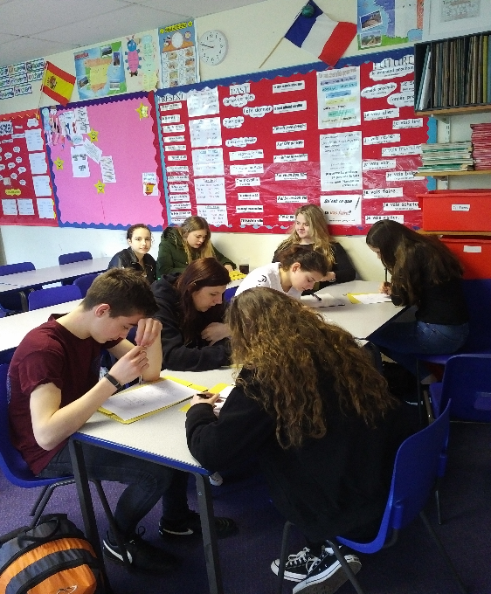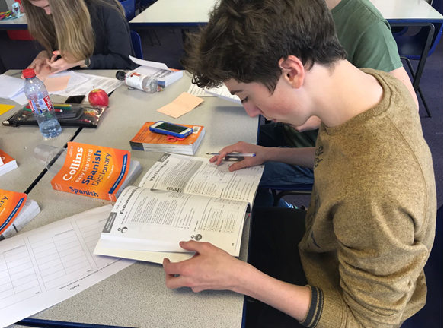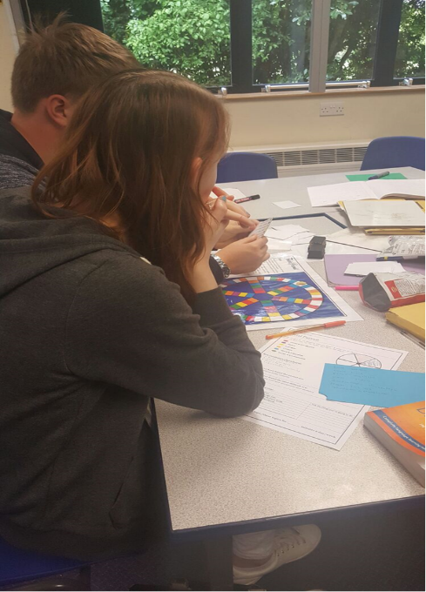

**What Can You Do To Support Your Child?**

**How the MFL department is supporting your child in his/her revision?**

* **Creation of revision booklets**
* **Vocabulary test every lesson from January 2018**
* **Weekly homework using revision booklet/GCSE revision workbook ( CGP)**
* **Revision workshops (French workshop: Wednesday 25th and Thursday 26th October from 9.30 am to 12.30). Future dates to be confirmed in February.**
* **Revision sessions held every Thursday ( Spanish and German) and Friday ( French) (3.15 to 4.15pm)**

**How can YOU support your child in his/her revision?**

* **Vocabulary learning**
* **Ensure that homework is completed on a regular basis (set at the end of each lesson from January).**
* **Encourage your child to take part in revision workshops and attend one revision session per week**
* **Exam practise (** [**www.AQA.com**](http://www.AQA.com)**)**
* 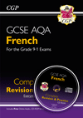 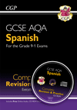 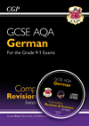

**Useful websites:**

* [**www.AQA.com**](http://www.aqa.com/) **( download some past examination paper)**
* [www.wildfrench.co.uk/GCSERevision.htm](http://www.wildfrench.co.uk/GCSERevision.htm)
* [**www.languagesonline.org**](http://www.languagesonline.org/)
* [**www.memrise.com**](http://www.memrise.com)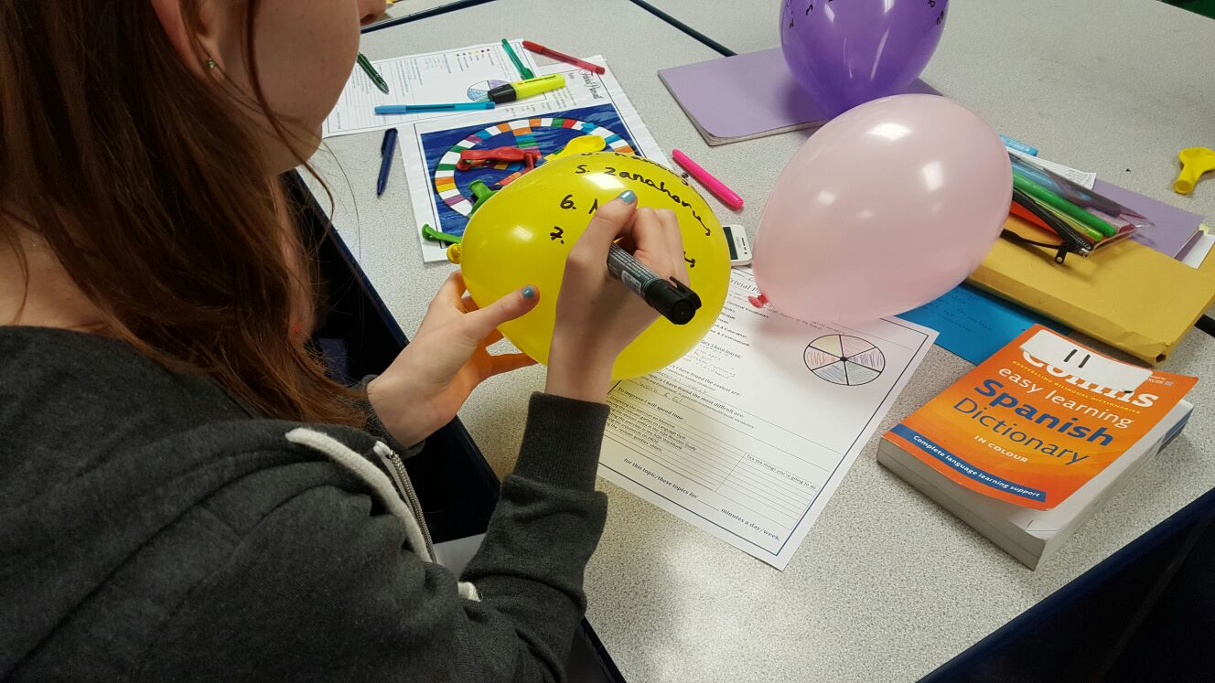
* **BBC bitesize**
* **Useful app to download : gojimo**