

**Exam Board Details:** Eduquas/WJEC

**COMPONENT 1: Principles of food preparation and nutrition**

Written examination - **1 hour 45 minutes**

50% of qualification

**COMPONENT 2: Food preparation and nutrition in action**

**Non-examination assessment: internally assessed, externally moderated**

**Assessment 1: 8 hours**

**Assessment 2: 12 hours**

**50% of qualification**

**What is being studied this year:**

**COMPONENT 1: Principles of food preparation and nutrition**

This component will consist of two sections both containing **compulsory questions** and will assess six areas of content:

1. Food commodities

2. Principles of nutrition

3. Diet and good health

4. The science of food

5. Where food comes from

6. Cooking and food preparation

**COMPONENT 2: Food preparation and nutrition in action**

|  |
| --- |
| **Assessment 1: The Food Investigation Assessment (15% of the course)**  **A scientific food investigation which will assess the learner's knowledge, skills and understanding in relation to scientific principles underlying the preparation and cooking of food.** |

**Pupil Task:**

Sugar is a main ingredient in cakes; however, as a nation we are encouraged to consume less sugar.

Investigate the working characteristics and the functional properties of sugar as an ingredient for cakes. Research whether it is possible to reduce the sugar content or use alternative ingredients without adversely affecting the result.

**Internal Deadline Date: 24/11/17**

**Font size should be 12/14; font should be Calibri.**

Food Preparation & Nutrition

Please also encourage your son/daughter to trial their chosen dishes for Assessment 2 at home – practice makes perfect!

|  |
| --- |
| **Assessment 2: The Food Preparation Assessment (35% of the course)**  **Prepare, cook and present a menu which assesses the learner’s knowledge, skills and understanding in relation to the planning, preparation, cooking and presentation of food.** |

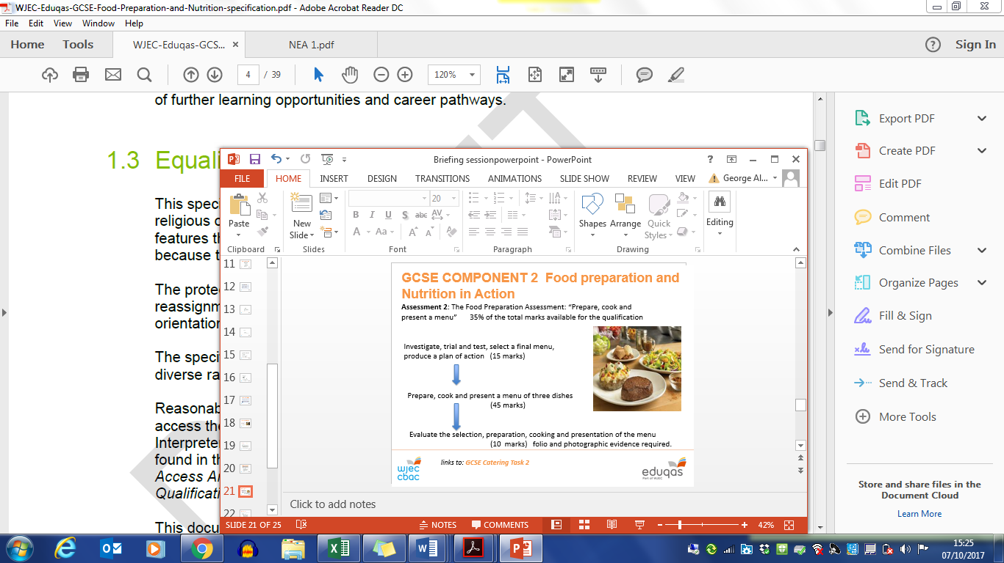

**Task will be released by the exam board 1/11/17**

**What Can You Do To Support Your Child?**

You can access the eduqas ***digital resources website*** for a range of resources to support revision for the written exam <http://resources.eduqas.co.uk/>

Please also use the resources listed below:

* **BBC Bite size for Design and Technology (Food Technology Section) also has lots of revision information.**
* **Exam question bank and ‘create an exam paper’ for ‘Food and Nutrition’ available via the WJEC exam board website**
* **EDUQAS revision guide (on loan from the department - issued to pupils in January)**

**The online ‘Illuminate Student Digital Book’ will support revision for all topic areas and has a selection of exam style questions.**

***For Illuminate Student Digital Book access:***

Please use the following username and password:

Student Username: SCAMS4

Student Password: STUDENT4