

Welcome to the first newsletter from Cams Hill School Art and Photography department. We would like to keep you up to date on what is going on here as much as possible. If you have any questions, please do not hesitate to contact us at school.

Pupils have hit the ground running since they returned in September. The Photography pupils have been busy adjusting to their new classroom, with adjoining studio and separate computer room. Whilst there have been a few teething difficulites getting used to the new computers and the internet filter updates, they are settling in amazingly. After-school catch up sessions have been well attended by all pupils, full details overleaf.

In Year 11, pupils complete a 10 hour mock exam during the Autumn term. The work completed for this mock is counted towards the final portfolio work. After the Christmas holidays pupils will be given their **exam** project brief. They will have to select from one of the themes given. The final 10 hour exam will take place in the Spring term. All work completed for this exam will count towards 40% of their final mark.

We following the AQA examining board programme for both GCSE Art, Craft and Design and GCSE Photography.

#### Art and photography department newsletter – YEAR 11

Art and Photography

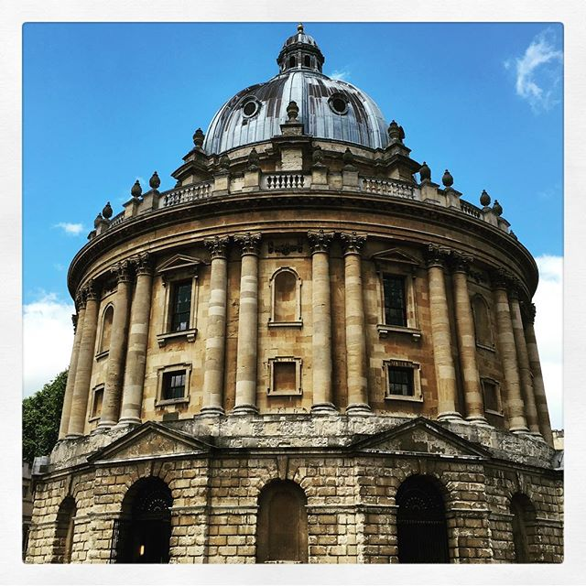

**What are we studying this term in Art, Craft and Design?**

During the second year of the Art, Craft and Design course year 11 pupils work on their ***Fantastic and Strange***project with a focus on ***Architecture***. Photographs and sketches taken from their trip to Oxford support this project and assist the development of ideas.

This term pupils have been asked to complete their artist research at home whilst lesson time has been devoted to building up primary observational drawings and experimenting with materials and techniques for assessment objectives 2 and 3. It is vital pupils spend at least two hours EACH WEEK on their art homework to ensure they complete this work prior to their November 10 hour mock exams.

**What are we studying this term in Photography?**

Pupils tool a wide range of photographs over the summer holidays in preparation for their Landscape and Architecture project. This will now lead into their second project ***Fantastic and Strange***. Photographs taken from their trips to Trafalgar Square, London and Oxford support this project and assist the development of ideas.

**What Can You Do To Support Your Child?**

Each week your child is expected to spend at least two hours working on their art/photography projects. If a child requires each support, advice or resources we offer the following sessions after school hours. Pupils may also speak to their teacher if further support outside of these times is required.

|  |  |  |  |
| --- | --- | --- | --- |
| **After School sessions…** | | | |
| When | What | Where | Who |
| Mondays  1515-1630 | Key Stage 4 Art Catch-Up Years 10 & 11 | Art 1/Art 2 | Supervised by Mrs Oswald-Cutler/Mrs Farmer |
| Monday (Week B only)  1515-1630 | Key Stage 4 Photography Catch-Up  Years 10 & 11 | Art 3 | Supervised by Mrs Hiron |
| Wednesday(Week B only)  1515-1630 | Key Stage 4 Photography Catch-Up Years 10 & 11 | Art 3 | Supervised by Mrs Hiron |
| Thursdays  1515-1630 | Key Stage 4 Photography Catch-Up Years 10 & 11 | Art 2/Art 3 | Supervised by Mrs Hiron (Wk B)/ Mrs Oswald Cutler (Wk A) |
| Thursdays  1515-1630 | Key Stage 4 Art Catch-Up Sessions | Art 1/Art 2 | Supervised by Mrs Oswald-Cutler/Mrs Farmer |

**Need help?** Camscreative is on Instagram, twitter and Pinterest. Work by students is showcased here with information about trips, catch-up sessions, competitions, holiday workshops and other news. Pinterest is an amazing visual resource, great for researching artists and techniques.

