Sleeping Well for exam success
While you want heaps of energy during the day, come bedtime ensure your body and mind are ready to rest. Lack of sleep will make it impossible to understand the hardest of questions let alone anything else, and you'll be much more likely to reach for a sugary fix to get you through the learning lulls.
Warm milk and herbal teas before bed have a sedative effect, while a carb-rich snack an hour or so before you head upstairs will clear the way for sleep-inducing amino acids to reach the brain.
Getting enough sleep is vital to feeling and performing your best, which makes a good night’s rest particularly vital around exam time.
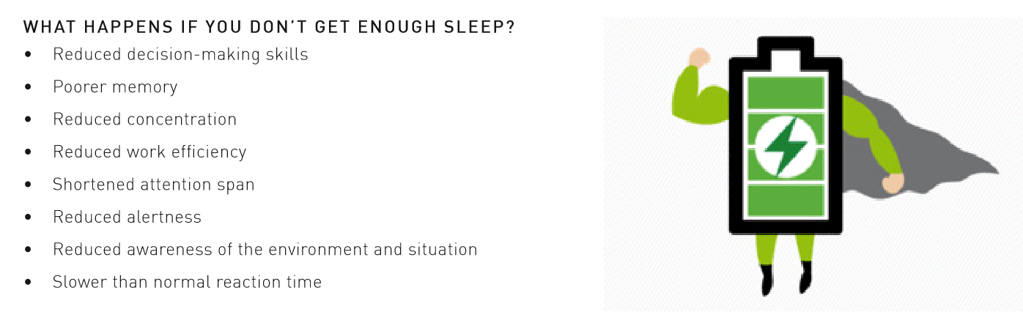
Read the following tips and advice to help you wake up fresh and prepared every morning.

How to sleep better during exams

1. Make time for sleep
The most important thing is to remember to schedule time for sleep. When you have to get up at a certain time, count back the number of hours you want to sleep and then add half an hour. This time becomes the scheduled time to switch the lights out. The extra half an hour is important - we often forget about the time it takes to brush teeth, set the alarm clock and so on.

2. Watch what you eat and when
Eating late meals because you have been studying all day will alter your internal clock and impair sleep. Although you should try not to go to bed hungry, try to have a big dinner before 7pm and then a smaller snack in the evening if you are still hungry. It’s thought that certain foods help sleep; turkey, milk, bananas, and walnuts all contain tryptophan, which the body uses to make melatonin.

3. Limit caffeinated drinks
Although the impact of caffeine varies from person to person, try avoiding all sources of caffeine from 3pm and adjust if needed. Remember caffeine isn’t just in coffee – it’s also in things like tea, chocolate, and fizzy drinks.

4. Make your bedroom a place of rest
Checking facebook or snapchat or doing some last-minute revision in bed may stop your brain associating the bedroom as a place of quiet rest and, instead, the bed becomes associated as a place of cognitive arousal. This can make it hard to initiate sleep, so remove all distracting items from the bedroom area.

5. Don’t use your smartphone in bed
Electronic devices emit noise and light; both will stop you sleeping. LCD screens on phones and tablets emit light that is blue enriched. This light influences the body’s internal clock (circadian rhythm) and delays the release of the ‘sleep hormone’ melatonin. Without melatonin, although you can sleep, the sleep you achieve will be light and non-refreshing. Light can also make you feel more alert, again training the brain to perceive the bed as a place of cognitive arousal.

6. Have a bedtime routine
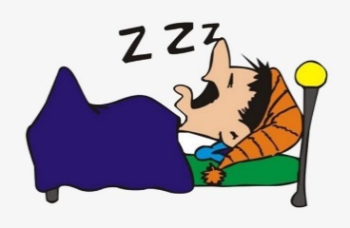
Doing exercise is a great way to relax during the exam period, as it causes the release of endorphins and improves your mood. However, the endorphins released from exercise can also impair sleep. As such, try to avoid exercising within two hours of bedtime. Instead, use those few hours to create a relaxing bedtime routine – perhaps by having a bath with lavender oil, or sitting and reading a book.

7. Clear your head before bed
There’s some truth in the old saying that taking a problem to bed means you wake up with the solution - but don’t let the problem keep you awake.
Sitting and ruminating over thoughts of the day will keep the brain active, so try keeping a notebook by your bed to write thoughts down before sleep instead. Meditation and breathing exercises can also help.
If you can’t drop off, don’t stay in bed trying to force yourself to sleep. Instead, employ the 15-minute rule: if you can’t sleep after what feels like 15 minutes, get up, leave the bedroom, and read or relax somewhere else. Only return to the room when you feel sleepy again.

8. Remember - one night of bad sleep won’t hurt
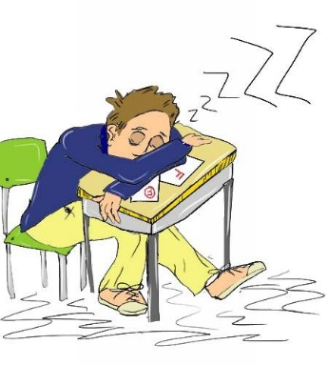
Your day may be more difficult and you might need more coffee to function, but you will make it through the day after one night of poor sleep. Sleep is an autonomic function – you can’t force yourself to sleep, so worrying about not sleeping or the effect of not sleeping on the following day will impair sleep.
Try not to nap, but if you need to, keep any naps to less than 30 minutes in length and don’t take them after 3pm. Remember, after a night of poor sleep, you are more likely to sleep the following night!

