Exercising for exam success
A healthy body means a healthy mind. Take care of yourself during the exam period by eating well, sleeping well and exercising regularly.
Exercise helps to oxygenate the brain and release tension, helping you to keep calm, mentally relax and study more efficiently.
Read these exercise tips and healthy lifestyle advice to help you beat revision and exam stress.

Top exercise tips

1. Little and often
You spend a great deal of time sitting at the computer or with your head in a book when revising for exams. You can’t revise effectively for excessively long periods, so take regular breaks to stay productive. A simple walk to the shops can be enough to help you clear your head so that you return refreshed to your studies.

2. Develop a routine
A balanced routine of work and play is essential during revision and exam time. It might feel like you’re too busy, but try to maintain a regular exercise schedule - aim to get active at least every other day.
Exercise releases endorphins that make you feel good, reducing stress and helping you to get good night’s sleep - but avoid stimulating activity just before bed, to give your brain time to wind down.

3. Know what works for you
Plan your exercise during periods when you know you generally won’t study. Some people work better in the morning, some in the evening – if you plan your exercise around your study schedule then you won’t miss out on valuable revision time.

4. Use your feet
If the school is close to where you live, why not walk or cycle instead of getting a lift or taking the bus? A short walk before an exam helps you to relax and focus your thoughts.
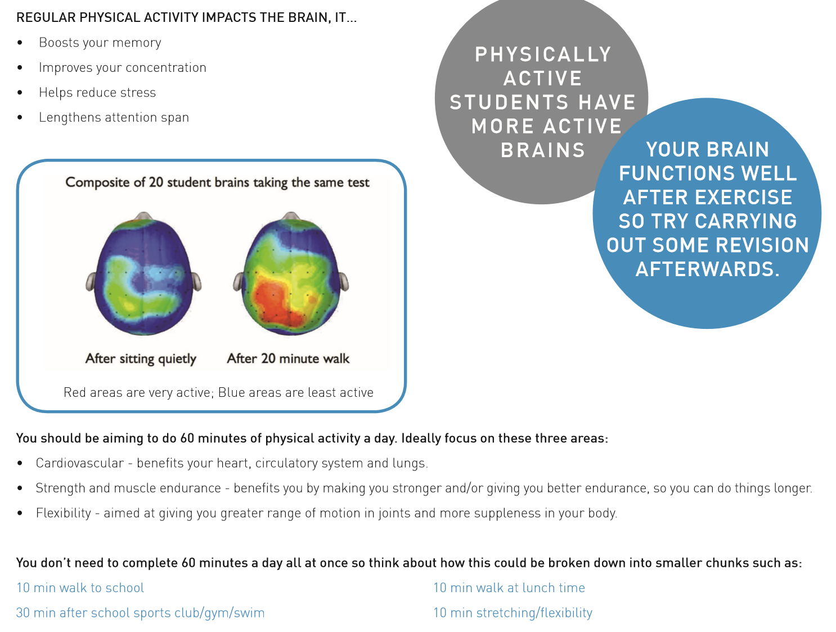

Eating for exam success
Discover what you should eat – and what you should avoid – to help you perform your best during revision and exams.

What to eat during exams
The following top healthy eating tips are from the University of Surrey’s Department of Nutritional Sciences designed to help you stay on top of your game during exam season.

1. Eat proper meals
Meals with slow release carbohydrates will help fuel your revision. When at school during the day, make sure you have a good breakfast and lunch. In the evening, make sure you have a good lunch and dinner.

2. Keep hydrated
Drink plenty of fluid. Go for plain water mainly, with the occasional diluted fruit juice or squash.

3. Eat plenty of fruit and vegetables
Use fruit and veg as a healthy snack instead of crisps, chocolate or fizzy drinks.

4. Watch your coffee intake
Caffeine acts as a stimulant and may aid concentration in small doses (the equivalent of one to two cups) but overdoing the caffeine will dehydrate you, can cause palpitations and may disturb your sleep.

5. Try to avoid energy drinks
High-sugar, high-caffeine drinks may appear to give you an instant buzz but are a poor substitute for proper food and fluid.

6. Avoid too many ‘treats’
Don’t overindulge on fatty foods, sugary snacks (crisps and chocolate) or fizzy drinks.

7. Don’t overdo the alcohol
You might feel more relaxed, but alcoholic drinks dehydrate you, disturb your sleep and can wreck your concentration the next day.
8. Pre- Exam Eating
Try to have a light meal before your exam, enough to give you energy through the exam – hence a meal including wholegrain carbohydrate but not too much that you feel sleepy and lethargic.
Ideas for Breakfast
• Porridge and dried or fresh fruit
• Weetabix, shredded wheat, muesli or similar wholegrain cereal and fresh or dried fruit
• Egg (boiled, poached, scrambled, fried) with wholemeal bread or toast
• Yogurt with seeds, nuts and fruit
• Low sugar cereal bar and a glass of milk
Some Smoothie Recipes to power you through the exam season
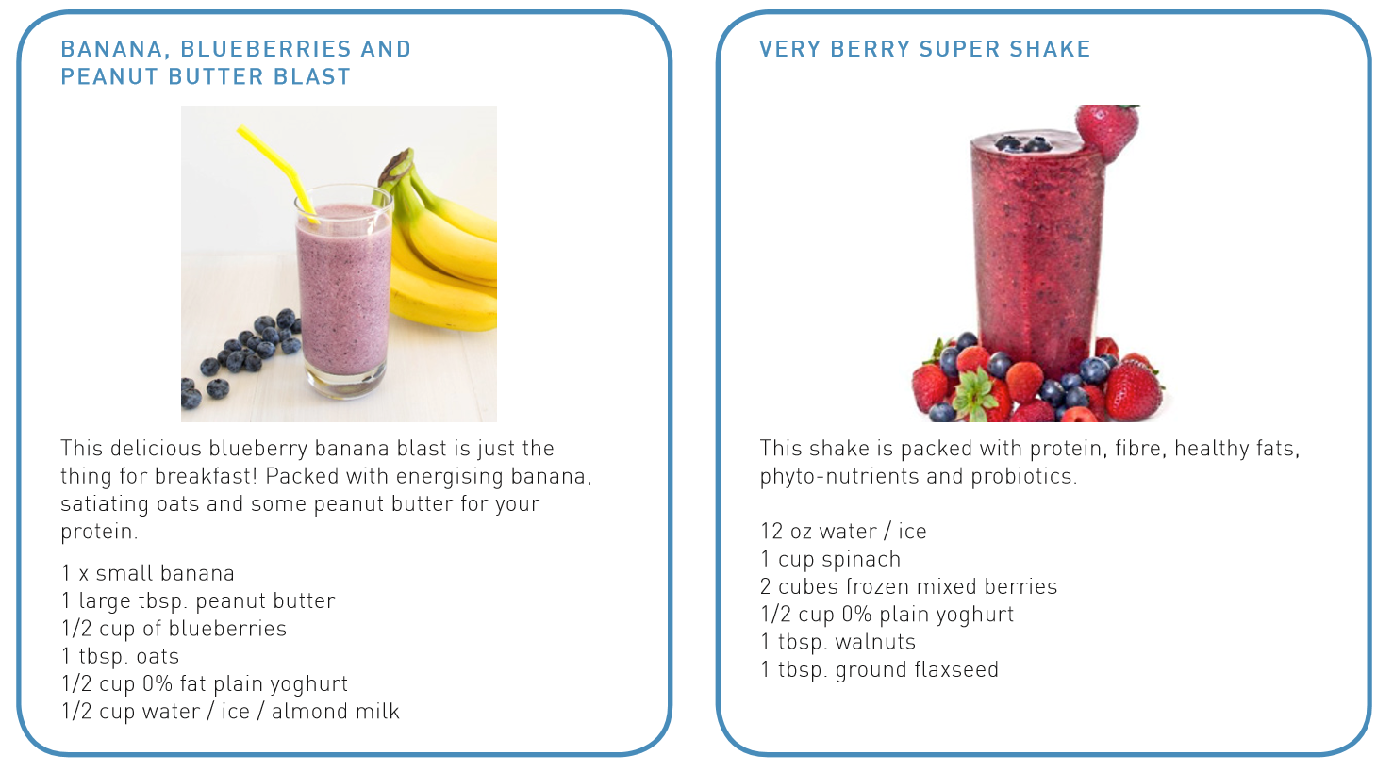
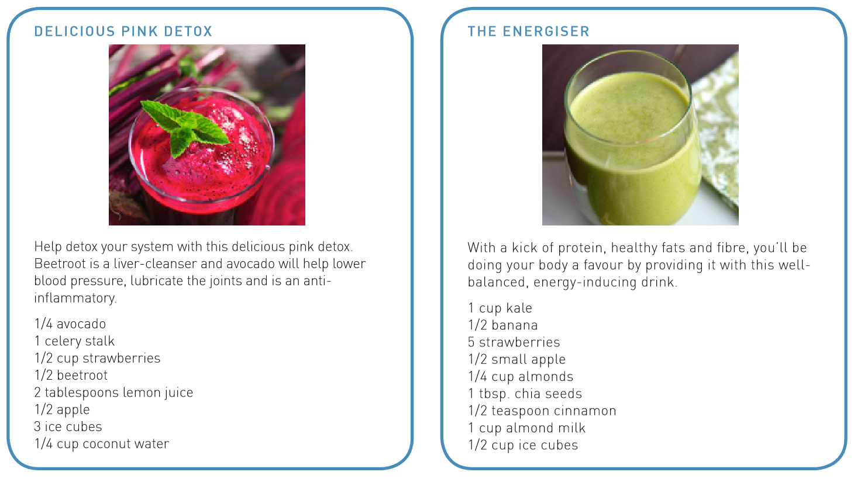

Sleeping Well for exam success
While you want heaps of energy during the day, come bedtime ensure your body and mind are ready to rest. Lack of sleep will make it impossible to understand the hardest of questions let alone anything else, and you'll be much more likely to reach for a sugary fix to get you through the learning lulls.
Warm milk and herbal teas before bed have a sedative effect, while a carb-rich snack an hour or so before you head upstairs will clear the way for sleep-inducing amino acids to reach the brain.
Getting enough sleep is vital to feeling and performing your best, which makes a good night’s rest particularly vital around exam time.
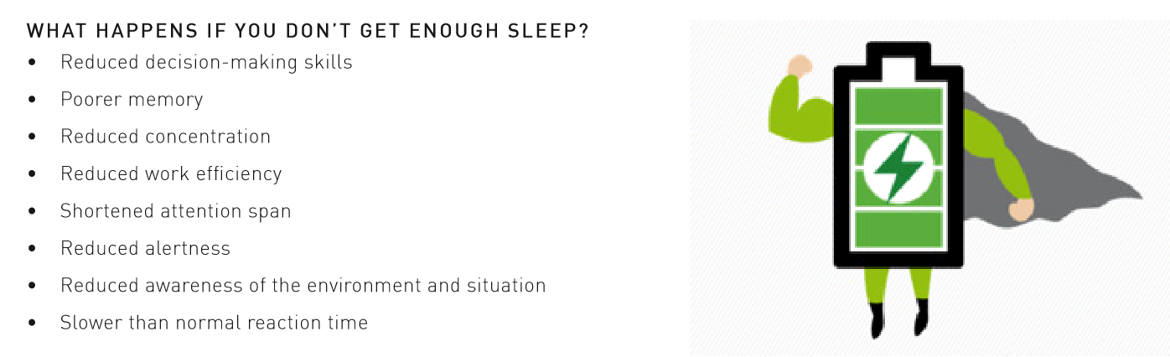
Read the following tips and advice to help you wake up fresh and prepared every morning.

How to sleep better during exams

1. Make time for sleep
The most important thing is to remember to schedule time for sleep. When you have to get up at a certain time, count back the number of hours you want to sleep and then add half an hour. This time becomes the scheduled time to switch the lights out. The extra half an hour is important - we often forget about the time it takes to brush teeth, set the alarm clock and so on.

2. Watch what you eat and when
Eating late meals because you have been studying all day will alter your internal clock and impair sleep. Although you should try not to go to bed hungry, try to have a big dinner before 7pm and then a smaller snack in the evening if you are still hungry. It’s thought that certain foods help sleep; turkey, milk, bananas, and walnuts all contain tryptophan, which the body uses to make melatonin.

3. Limit caffeinated drinks
Although the impact of caffeine varies from person to person, try avoiding all sources of caffeine from 3pm and adjust if needed. Remember caffeine isn’t just in coffee – it’s also in things like tea, chocolate, and fizzy drinks.

4. Make your bedroom a place of rest
Checking facebook or snapchat or doing some last-minute revision in bed may stop your brain associating the bedroom as a place of quiet rest and, instead, the bed becomes associated as a place of cognitive arousal. This can make it hard to initiate sleep, so remove all distracting items from the bedroom area.

5. Don’t use your smartphone in bed
Electronic devices emit noise and light; both will stop you sleeping. LCD screens on phones and tablets emit light that is blue enriched. This light influences the body’s internal clock (circadian rhythm) and delays the release of the ‘sleep hormone’ melatonin. Without melatonin, although you can sleep, the sleep you achieve will be light and non-refreshing. Light can also make you feel more alert, again training the brain to perceive the bed as a place of cognitive arousal.

6. Have a bedtime routine
Doing exercise is a great way to relax during the exam period, as it causes the release of endorphins and improves your mood. However, the endorphins released from exercise can also impair sleep. As such, try to avoid exercising within two hours of bedtime. Instead, use those few hours to create a relaxing bedtime routine – perhaps by having a bath with lavender oil, or sitting and reading a book.

7. Clear your head before bed
There’s some truth in the old saying that taking a problem to bed means you wake up with the solution - but don’t let the problem keep you awake.
Sitting and ruminating over thoughts of the day will keep the brain active, so try keeping a notebook by your bed to write thoughts down before sleep instead. Meditation and breathing exercises can also help.
If you can’t drop off, don’t stay in bed trying to force yourself to sleep. Instead, employ the 15-minute rule: if you can’t sleep after what feels like 15 minutes, get up, leave the bedroom, and read or relax somewhere else. Only return to the room when you feel sleepy again.

8. Remember - one night of bad sleep won’t hurt
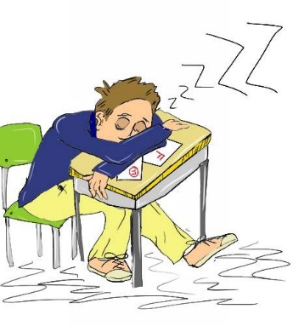
Your day may be more difficult and you might need more coffee to function, but you will make it through the day after one night of poor sleep. Sleep is an autonomic function – you can’t force yourself to sleep, so worrying about not sleeping or the effect of not sleeping on the following day will impair sleep.
Try not to nap, but if you need to, keep any naps to less than 30 minutes in length and don’t take them after 3pm. Remember, after a night of poor sleep, you are more likely to sleep the following night!

Mental Energy for exam success
Our minds are one of the biggest contributors to energy levels.
High levels of mental energy can lead to increased happiness, confidence, focus, willpower, motivation and productivity – all significant benefits for getting through exam periods, but also everyday life.

What exactly is mental energy?
- Mood – whether we think positively and therefore perform well.
- Motivation and willpower – whether we take initiatives, seize the moment with determination or procrastinate.
- Focus – whether we are effective for the duration a task needs.
- Confidence – how we perceive ourselves and our abilities, we know that this has a direct effect on our performance.

How will boosting your mental energy benefit you?
- Improving our mental energy helps us to feel more positive, more confident and more determined.
- By feeling more positive, confident and determined, we will be more focused and motivated.
- By becoming more focused and motivated, we will accomplish more.

How can you boost your mental energy?
- Surround yourself with people who make your happy, who support you and think positively.
- Take steps to change your mindset and think positively.
- Declutter your mind – set reminders, keep a diary, make a timetable. Get as much ‘out of your mind’ so that you can relax.
- Have fun! Always remember it’s important to have time doing things you enjoy.
- Get outside – vitamin D helps to boost energy levels.
- Stimulate your mind – don’t stick to the same ways of revising. Challenge yourself, do things differently.
- Focus on small steps and what is in your control – worrying about something we can’t affect can cause anxiety. Break goals down into manageable steps that you can control.
- Take responsibility for your emotions – if you’re feeling sad that will affect your mental energy so find ways to help improve your mood and emotions, whether that’s doing a hobby or talking to someone about how you feel.

For tips to beat exam stress have a read of the following:
http://www.studentminds.org.uk/examstress.html
https://www.childline.org.uk/globalassets/info-and-advice/school-work-and-college/school-and-college/exam-stress/beat-exam-stress.pdf
http://www.bbc.co.uk/programmes/articles/1HsY1X8ySjKBMVXPVCbP4qH/exam-stress

