**Reading List/Revision List for Literature and Language**

**AQA English Language: Spec 8700 AQA English Literature: Spec 8702**

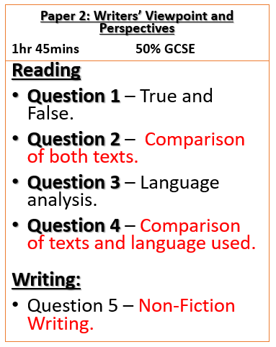 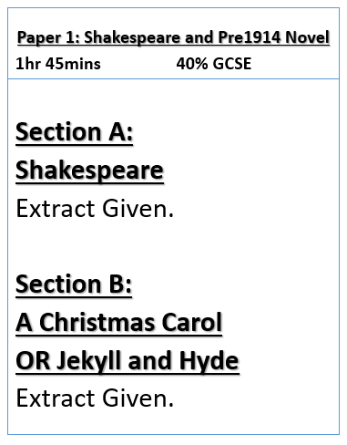

Your son/daughter will be sitting exams for English Literature and English Language in the summer of 2019. It is therefore essential that given the vast content of the subjects, they begin a structured revision programme over the next 7 months. I would recommend that they re-read core texts studied and it is advantageous to access one of more of the following revision guides. There are a number of second hand copies of the texts below via eBay and Amazon.

Our exam board also has a past paper and mark scheme that may be helpful – the address for this is:

<http://www.aqa.org.uk/subjects/english/gcse/english-literature-8702/assessment-resources>

<http://www.aqa.org.uk/subjects/english/gcse/english-language-8700/assessment-resources>

|  |  |
| --- | --- |
| **Book** | **ISBN** |
| **A Christmas Carol – CGP Guide** | 978-1782943099 |
| **Macbeth – CGP Guide** | 978-1841461168 |
| **Inspector Calls – CGP Guide** | 978-1841461151 |
| **AQA English Language text books** | Book 1: 9780198340744  Book 2: 9780198340751 |

Finally, BBC Bitesize offers good revision areas – again, I have listed these below:

|  |  |
| --- | --- |
| **Website** | **Topic** |
| **BBC Bitesize** | **A Christmas Carol:**  [**http://www.bbc.co.uk/education/topics/zcs8qty**](http://www.bbc.co.uk/education/topics/zcs8qty)  **An Inspector Calls:**  [**http://www.bbc.co.uk/schools/gcsebitesize/english_literature/dramainspectorcalls/**](http://www.bbc.co.uk/schools/gcsebitesize/english_literature/dramainspectorcalls/)  **Macbeth**  [**http://www.bbc.co.uk/schools/gcsebitesize/english_literature/dramamacbeth/**](http://www.bbc.co.uk/schools/gcsebitesize/english_literature/dramamacbeth/) |
| **Sparknotes** | **A Christmas Carol/Jekyll and Hyde**  **An Inspector Calls**  **Macbeth** |

