

**What is being studied this year:**

* Generating design ideas and design development
* Drawing for design using hand and CAD drawing methods.
* 3D modelling techniques.
* Materials, techniques and processes
* Social and moral issues
* Planning for manufacture
* Product manufacture – 3D practical element
* Mock GCSE Exam preparation
* Exam preparation - Review of design theory, knowledge of materials and processes and skills learnt.

The Pearson Edexcel Level 1/Level 2 GCSE (9–1) in Design and Technology consists of one externally-examined paper and one non-examined assessment component. Students must complete all assessment in May/June in any single year.

**Component 1 - Written examination:** 1 hour and 45 minutes 50% of the qualification 100 marks

**Content overview**  – Consists of core content and then information on following material categories: Timbers

**Assessment overview** - The paper consists of two sections. **Section A** is assessed on the core content and **Section B** is assessed on the material category - Timbers

**Section A:** **Core** This section is 40 marks and contains a mixture of different question styles, including open-response, graphical, calculation and extended-open-response questions.

There will be 10 marks of calculation questions in Section A.

**Section B:** **Material categories** This section is 60 marks and contains a mixture of different question styles, including open-response, graphical, calculation and extended-open-response questions.

There will be 5 marks of calculation questions in Section B.

Calculators may be used in the examination for the calculation questions.

**Component 2 - Contextual Challenge**

Students will undertake a project as part of their non-examination assessment which will be set by the exam board. The project will test students’ skills in investigating, designing, making and evaluating a prototype of a product that will allow them to apply the skills they have acquired and developed throughout their study.

Students are required to analyse a given contextual challenge from a range of three on an individual basis. Having selected a contextual challenge to work within, students should develop a range of potential ideas and then realise one through practical making activities. The project must allow students to apply knowledge and understanding in a product development process to investigate, design, make and evaluate their prototype.

This project will require students to follow an iterative design process rather than a linear process requiring them to continually test, evaluate and refine ideas. The content and assessment criteria are set out in a linear format to show what is required at each stage of the total project, but following an iterative process students will do work on different stages at a variety of points thorough their project.

Design and Technology

**What Can You Do To Support Your Child?**

Catch up sessions run every **Mondays 3.20 – 4.40**

**And some Thursdays depending on meetings**

**Useful websites:**

www.technologystudent.com

www.mrdt.com

[www.gcsebitesize.com](http://www.gcsebitesize.com)

[www.dtonline.org](http://www.dtonline.org)

[www.designandtech.com](http://www.designandtech.com)

[www.design-technology.info](http://www.design-technology.info)

Don’t forget to check out <https://uk.pinterest.com> great for looking at innovative new products and for learning drawing and workshop techniques.

**Books for Controlled Assessment coursework and Revision:**

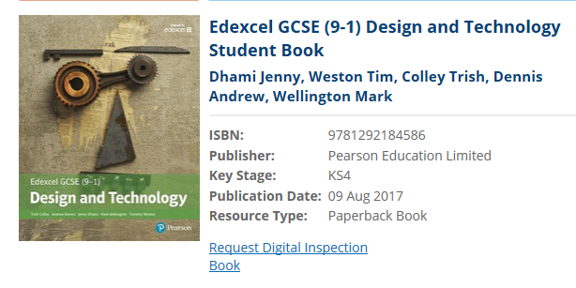

The school has an electronic copy of this and there will be a structured revision programme set up using this resource, with worksheets to help summarise the learning. They also have the revision books purchased last year.

All students must practice and use relevant Computer Aided Design software.

**Tinkercad.com** and **Google SketchUp.com** are free online and downloadable design software that all Product Design students should be learning to use. Tutorials with the software will help to develop skills. Some class time will be given over to familiarising the use of CAD but this can also be regularly practiced at home. There will also be an afterschool masterclass at the appropriate time in the contextual challenge.

Practical work, testing and trialling of prototypes will take up most of the class time during the latter part of the autumn term. The practical which includes prototyping, testing trials accounts for many marks but must be supported in the written aspect to secure the higher grades.

**How else can you help?**

You can support your child by overseeing that they complete 1-2 hours of homework per week. This could be a combination of revision, students independently set and teacher targets for contextual challenge assessment work.

An ideal way to support your child would be to help proof read written work in their contextual challenge assessment folder and support them with gathering materials for their practical outcome. They will also need client feedback on design proposals and prototypes.